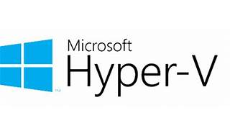

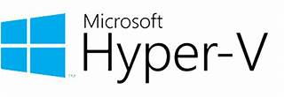

Explore

**Hyper-V** is **Microsoft’s hardware virtualization product** that allows you to create and run virtual machines (VMs), each acting like a complete computer with its own operating system and programs. It provides flexibility, efficient hardware utilization, and isolation for workloads. Here are some free resources to learn more about Hyper-V:

1. [**Microsoft Learn: Hyper-V Technology Overview**](https://learn.microsoft.com/en-us/windows-server/virtualization/hyper-v/hyper-v-technology-overview): This article provides an overview of Hyper-V, its features, and how it can benefit you.
2. [**Introduction to Hyper-V on Windows 10**](https://learn.microsoft.com/en-us/virtualization/hyper-v-on-windows/about/): Learn how to get started with Hyper-V on Windows 10, including installation, creating virtual machines, and using PowerShell.
3. [**Hyper-V Virtualization Technology**](https://www.sysnettechsolutions.com/en/hyper-v-virtualization-technology/): Explore this guide to understand how Hyper-V lets you operate multiple virtual operating systems on a single physical computer.
4. [**Hyper-V Online Training Course**](https://www.cybrary.it/course/hyper-v): Dive into building, configuring, and managing virtual machines using Hyper-V in both server and client environments.
5. [**Windows Server Hyper-V and Virtualization Training**](https://learn.microsoft.com/en-us/training/paths/windows-server-hyper-v-virtualization/): Learn best practices for preparing Hyper-V hosts, networking features, and implementing nested virtualization.

Feel free to explore these resources to enhance your knowledge of Hyper-V! 🚀🔍